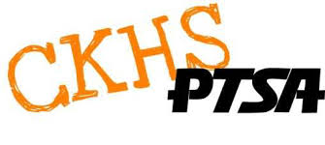
CKHS PTSA GRANT REQUEST APPLICATION
CKHS staff members may apply for funds for materials to enhance the classroom learning experience and/or the school environment.
GUIDELINES: One request, maximum of $100.00 per staff member, per academic year. Items purchased are the property of CKHS and remain at CKHS regardless of status of requesting staff member. Funds are not available for extra-curricular activities. Funds cannot be used for staff development, substitute pay, compensation for time spent, transportation, or similar items.

Completed applications will be considered at the next CKHS Board Meeting. CKHS PTSA meets the second Wednesday of the Month at 4:00pm.

If approved, CKHS PTSA will make payment to vendor with proper invoice or to the staff member with proper receipt. CKHS PTSA cannot make payment without receipt(s).

Please complete and place in PTSA mailbox.
Name_______________________________Department_______________Date:____________

Purpose of Grant:

If more space is needed please attach a description of how you will use funds, including purpose and student benefit.

Approx. # of students this would beneft:________ Amount of Request:________(Max. $100.00)
PTSA Use. Date:_________________ Approved/Denied
Reason if denied:______________________________________________________________
Approval (Signature of 3 PTSA Board Members:
1)__________________________________________________________________________
2)__________________________________________________________________________
3)__________________________________________________________________________
Date Staff Member Notified of PTSA Decision:_______________________________________
Board Member Who Notified:_____________________________________________________

